# Introduction

## Project summary

As part of the UNSW Canberra City Vision, the university is seeking to expand its presence in through the establishment of a new multi-precinct campus in Reid, Canberra. The proposed site is situated inside Canberra’s CBD and within proximity the Parliamentary Triangle, as such the transport network that will service the site is already prone to high levels of congestion during peak periods.

The development will include designated car parks, however the number of spaces required will depend what alternatives are available to commuters. As part of the proposal the university is considering the following three options,

#### Free parking

Parking facilities at the nearby ADFA Campus are currently free for all staff and students. Under this proposal, parking would be free for the new Reid campus in order to maintain fairness.

#### Flat-rate parking

This proposal attempts to discourage private car use by charging commuters a daily flat rate of $5.00 per a parking space. Fewer parking spaces would be required, and in turn generate less additional congestion. The income stream would (presumably) be reinvested into providing efficient transport alternatives (such as on demand transport).

#### On Demand Transport

On Demand Transport (ODT) is a flexible public transport service designed to improve connections to transport hubs, town centres and other institutions. This proposal looks to provide ODT for the new Reid Campus.

The aim of this project is to estimate future demand for parking spaces in each of the above three proposals.

What does this report do? Might need to clarify

* Come up with an evaluation criteria
* Establish a modelling framework (iterated upon later)
* Identify relevant data and variables

The best solution is to most like to be a combination of all three proposals.

## Progress report

Discuss progress made (1 paragraph)

# Modelling Framework

Essentially rehash everything from tutorial 2 tasks.

## Flowchart

Something like this (but not this). Best to use cross classification method for trip gen.

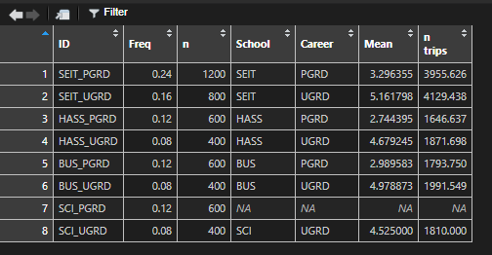

## Evaluation Criteria

|  |  |
| --- | --- |
| End-user | Description + scoring mechanism for each |
| Travel time/distance |  |
| Convenience/Practicality |  |
| Cost (to end-user) |  |
| University |  |
| Capital cost |  |
| Operating cost |  |
| Land use/displacement |  |
| Community |  |
| Potential for congestion |  |
| Noise pollution |  |
| Environmental footprint |  |
| Energy consumption |  |
| Safety |  |

## Endogenous and exogenous variables

## Input and output variables

Summarise all the variables from R script.

## Connections and models

Todo – brain dump

# Data Analysis

Need to summarise findings from R script here.